**GEOG 531**

**Assignment 1: Simple Python Programs**

For this assignment, you will submit two things: a word-processing document with your answers for Part A, and two PY files containing two forms: one form for each of the small programs in Part B. **This assignment is due at the end of your next Python class (1 week).**

**Part A: Determine the Output in the *Terminal* Window (6 marks)**

1. X = "Hello"

X = "Goodbye"

print(X)

1. X = "Hello"

print(X + " " + "World")

1. X = 5

X = X + 1

print(X)

1. X = 5 + 1 * 3

print(X)

1. X = 5 + 1 / 3

print(X)

1. X = "Hello123"

print(X + " is " + str(len(X)) + " characters")

**Part B: Small Programs**

Complete all programs based on code examples from the tutorials. **You will be evaluated on style** (control alignments and variable names, comments, white space) in addition to the requirements listed for each program.

1. **Name Length (6 marks)**

Create a very simple GUI program that reads a text string for a user’s name, and then tells you how many letters long your name is. Your program will have one textbox where the user enters a name (“Bob”, for example), and a button. When the button is pressed, a message box is displayed saying “Bob is 3 characters long”. Use a **variable** which gets assigned the name entered, and the length **len()** build-in function of the variable to determine length. Use the **concatenation (“+”) operator** to concatenate the name entered and the text describing the length of it. Use **messagebox** to display the result.

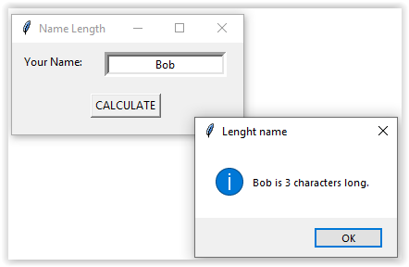

To use the Tkinter message box, you need to import its widget first as

from tkinter import messagebox

Insert this line after the line import tkinter as tk. See more about the Tkinter message box at <https://www.geeksforgeeks.org/python-tkinter-messagebox-widget/?ref=lbp>.

The code for your function will look something like the following. To complete the functionality, you will need to complete the first two statements of function and add one line at the bottom of function to cleanup text within the user entry textbox.

def calculate_Click():

    intLenght = … #get len() from assigned the name entered.

    messagebox.showinfo(…,…)

    #use the concatenation (“+”) operators to concatenate the name entered txtName.get()

    # and the texts describing the length of it as per the above print screen.

    #remove any former, old text from *Entry* with .delete(…) which needs the positions

    # where to start and end the deletion.

You might remove the instructional comments within the above functions as soon as soon as your code will work properly.

1. **Miles to Kilometres Converter (10 marks)**

Create a Python GUI program that will convert a user-specified value in miles to values in kilometers. Your form should appear something like that shown below:

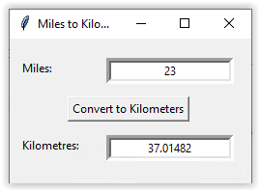

As part of this program, you must:

* Correctly convert values from miles to kilometers.
* Use two textbox controls: one for the input in miles, and one for the output in kilometers.
* Set focus() method on the input textbox.
* Change at least one property which changes the way the form appears. For example, you could change the font of a label, or the background color of the textbox.

*NOTE: this program will fail with an error if you enter text in the Miles textbox. This is OK – we will learn next week how to fix that.*

**Submission:**

Compress (e.g., zip) the word-processing document for Part A and two PY script files for Part B together and submit the resulting compressed file in Desire2Learn.